**Curriculum Introduction**

This curriculum provides an instructional approach for the delivery of career services, and it is multimedia-based. The curriculum can be delivered by instructors, counselors, or advisors. It also can be used as the nucleus of a three-credit course. The nine instructional modules (units of curriculum) target specific community college counseling goals and are structured around behavioral objectives.

These objectives provide a great opportunity for accountability in the evaluation of services, as they are behavioral objectives, and assessments of lesson objectives are linked to the behavioral indicators of the National Career Development guidelines. Effectiveness of materials and instruction can be measured in relation to specific objectives. So the system offers the ability for continual upgrading and enhancement of each instructional unit. As information and technology change, the curriculum can be readily upgraded to keep pace. And as new needs emerge, additional modules can be developed and added.

Each module stands independently. One instructor might choose to conduct a module linked to choosing a major; a business instructor might choose lessons on labor market forecasting; a discovery program instructor might seek some fresh materials on integrating lifestyle and career. This curriculum makes all of these options possible. This multifaceted approach eliminates the necessity of prescribing the same services for everyone.

Hopefully, this model also provides an attractive means of engaging instructional staff in career exploration activities that are goal and outcome-driven. According to author Vernon Zunker, career services that provide the opportunity to identify goals and desired outcomes have much greater instructional appeal and better assist the student in identifying expectations of career services.[[1]](#endnote-2)

Each unit includes a multimedia PowerPoint presentation, designed to be projected amid instruction. Alternatively, slides can be printed from these presentations and used as overheads. Detailed lecture notes regarding the use of these materials are included when necessary. Step-by-step instructions for the full delivery of each module are provided, as well as a listing of materials, precursory preparation steps and assessment strategies.

Career-related problem solving and decision-making are cyclical, according to CIP theory, and students need to both understand this cycle and where they are within the cycle. The cycles can be remembered by using the mnemonic “CASVE,” pictured in Figure 1 below, where you will see that CASVE stands for:

**Step 1: Communication**

An articulated external demand may serve as the communication prompt; for example: "I need to choose a major by next semester." Alternatively, a significant other may enlighten the individual: "My roommate says I'll have problems if I don't make a decision soon." Or the individual may perceived an internal affective, behavioral, or physiological state, such as an emotion: "I'm scared about committing myself." Or the person may feel like procrastinating: "I'll get started next week," or they may literally feel ill: "I'm so stressed out about this, I can't eat."

**Step 2: Analysis**

Analysis enhances self-knowledge, which can be obtained from personal experience, structured experiences-such as these modules, formal assessment instruments, and computer-assisted career guidance systems). These experiences clarify values, interests, skills, personality, aptitudes, and employment preferences.

This analysis also enhances occupational knowledge by identifying important characteristics of occupations, programs of study, or jobs and knowledge of individual occupations, programs of study, or jobs (obtained from print material, audio-visual material, CACG system, information interviews, shadowing, work experience, academic courses, etc.). Ideally, this analysis also expands knowledge of the structure of the world-of-work (occupations, programs of study, or jobs) from the Holland Hexagon, World-of-Work Map, or other framework. Students participating in these analytical processes enhance generic information processing skills and learn more about their metacognitions, such as their self-talk (I need to make a decision), self-awareness (I'm uneasy about this whole process), and their control and monitoring (What information do I need to obtain about myself and the situation to make a decision?).

**Step 3: Synthesis**

Synthesis involves the elaboration and crystallization of options. Putting together the pieces of the puzzle, so to speak. During synthesis, students identify the maximum number of potential alternatives (occupations, programs of study, or jobs). During the crystallization process, students narrow potential occupations, programs of study, or jobs to a manageable number of options for exploration (3-5).

## Step 4: Valuing

Valuing involves judging, prioritizing, and making choices. Students learn to judge the costs and benefits of each alternative to themselves, significant others, their cultural group, community and/or society. Next they prioritize among alternatives and make tentative primary and secondary choices.

**Step 5: Execution**

In the execution step, students formulate a plan for implementing a tentative choice. This execution may include preparing for formal education or training, reality testing (work experience of some sort or exploratory coursework). It might also involve employment seeking.

**The CASVE Cycle Figure 1.**

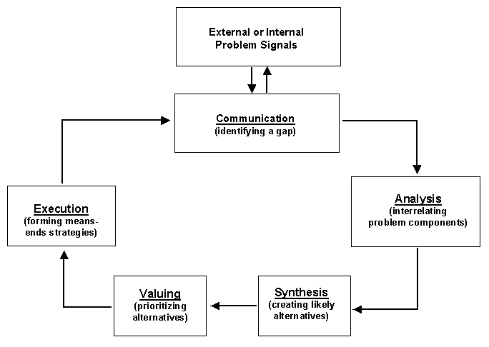

C:\Users\Susan\AppData\Local\Microsoft\Windows\Temporary Internet Files\Content.IE5\HQD0I7WI\MCBS00867_0000[1].wmfThis cycle, coupled with the National Career Development Guidelines inspired the creation and design of the following nine instructional modules.

Please note, within this curriculum, worksheets and student handouts are denoted with a symbol in the upper right hand corner of the curriculum. It looks like this:



Lecture notes have a different symbol in the upper right hand corner. The symbol looks like this:

Many thanks to the Oregon Career Information and Cheryl Buhl, who provided me the opportunity to develop curriculum-writing skills during eighteen years of my work life. The roots of several of the activities contained here within began many years ago with Oregon CIS.

1. Zunker, V. (1998). Career counseling: applied concepts of life planning. Brooks/Cole Publishing: Pacific Grove, CO. page 259. [↑](#endnote-ref-2)