[MODULE 1: What Is Involved in Making a Career Decision?](module%201%20slides.pptx)

Summary

Students review myths associated with career decision-making. Students learn the elements of career choice and the steps in the process of good career choice. Students also learn to prioritize the factors associated with making a decision and complete a decision-making matrix for a simple list of factors.

Objectives

*Students will . . .*

* Debunk myths about career choice
* Learn the elements and the steps in the process of good career choice
* Prioritize factors associated with their own career decision-making
* Learn to use a decision-making tool.

National Career Development Guidelines Goal(s)

* GOAL CM2 Use a process of decision-making as one component of career development.

Time Required

~40-50 minutes

Preparation

* Review *Elements of Career Choice, Lecture Notes*
* Review *Steps in Good Decision-Making, Lecture Notes*
* Make photocopies of both *Five Myths about Career Planning and Decision-Making* and *Learning to Prioritize*, one per student
* Either create overheads from Unit 1 slide show (PPT) or arrange for computer and projection system to show slides

Materials

*Five Myths about Career Planning and Decision-Making handout*

*Learning to Prioritize handout*

Unit 1 slideshow or overheads

Steps

**LESSON ONE**

1. Overview class agenda, using Slide 1.
2. Next, show Slide 2. Ask students to cite reasons that these are myths.
3. Handout *Five Myths about Career Planning and Decision-Making.* Pair students and ask pairs to discuss this handout for a few minutes.
4. Pairs report findings to full group.
5. Show Slide 3. Explain to students that the pyramid graphically portrays the elements of career decision-making. Point to the bottom box in the pyramid, and, using page one of the lecture notes, explain the pyramid.
6. As you introduce *Knowing about My Options* and the Holland Information, place Slide 4 on the screen and briefly explain Holland Typology, using the lecture notes (This typology will be covered more fully in Module 2, should you choose to use this as well).
7. Ask students to identify which type most sounds like them.
8. Review the remainder of the pyramid, using information from the lecture notes, page 2.
9. Introduce Slide 5, Steps in Making a Good Career Decision, using the lecture notes to help you walk through this graphic. Ask students to identify where they see themselves on this graphic and explain that career development is a lifelong process that repeats itself, often several times.

**LESSON TWO**

1. Introduce prioritizing using the handout (prioritizing is defined as identifying and organizing actions/plans/decisions around what is most important to you and giving those factors more attention, energy, and focus). Explain that prioritizing is a valuable life and career skill because it helps you make decisions by helping you focus on what’s more important at the expense of less important things.
2. Explain that prioritizing is about making choices of what to do and what not to do based on really thinking about what is important to you. To prioritize effectively, you need to be able to recognize what is important, as well as to see the difference between urgent or “noisy” and important. Important or high priority factors are those that help you achieve your long-term goals or can have other meaningful and significant long-term consequences.
3. Distribute the *Learning to Prioritize* handout and place Slide 6, the sample grid on the overhead. Walk through the process using the sample on the overhead.
4. Next, show Slide 7 and ask students to complete a prioritizing grid for themselves for practice, using the song assignment noted at the bottom of the handout. Either collect these or assign as homework.

Assessment Strategies

Ask students to complete one or more of the following:

|  |  |
| --- | --- |
| CM2.K1 | Complete prioritizing worksheet, describing one's own decision- making style (e.g., risk taker, cautious). |
| CM2.A1 | Give examples of past decisions that demonstrate your decision-making style. |
| CM2.R1 | Evaluate the effectiveness of your decision-making style. |
| CM2.K2 | Identify the steps in one model of decision-making. |
| CM2.A2 | Demonstrate the use of a decision-making model. |
| CM2.R2 | Assess what decision-making model(s) work best for you. |

**C:\Users\Susan\AppData\Local\Microsoft\Windows\Temporary Internet Files\Content.IE5\HQD0I7WI\MCBS00867_0000[1].wmf5 Myths about Career Planning & Decision-making**

**#1 Choosing a career is easy**

Choosing a career is very complex, and it takes *quality* time. Career development involves learning about oneself, learning about occupations and associated training programs, then bridging these pieces of information for planning and decision-making.

**#2 Money is the key to happiness**

Wages *may* be important, but they are not the only factor you should consider nor perhaps the most *important* factor you should consider when choosing a career. High wages are *not* linked to occupational satisfaction, according to the most current research findings[[1]](#footnote-2). For most people, enjoying their work tasks, feeling skilled and recognized for a job well done, and having positive coworkers are seen as much more important factors than money. Considering wages is important, but don’t let wages drive your selection process.

**#3 You will learn to hate your hobby if it becomes your career**

Marcia Sinetar wrote an inspiring book entitled, **Do What You Love, the Money Will Follow**. In this book, she observes that you are likelier to be successful if you work in a field you care about than if you just punch a timecard. It makes good sense to choose a field related to what you enjoy doing and do well. You are likely quite skilled in several aspects of your hobby, and those skills may transfer nicely to a new career field.

**#4 Hot “Careers of the Future” should guide my choice**

Occupational outlook information can help inform you about fields that interest you, but don’t let outlook information guide your choice. Forecasts are typically based on valid data and formulas, but sometimes the economy changes rapidly and unexpectedly, as ours did following the events of 9/11. Just because the outlook for an occupation looks good, it doesn't mean that the occupation is right for you. Consider your interests, skills and other preferences first.

**#5 Others know better than I what career would be best for me**

A career counselor, family member, or friend should ***not*** tell you what occupation is best for you. Others can provide you with insights into yourself and the workforce, and they can provide you with assistance in making choices, but ultimately, the decision must be your own. You know yourself best, and you can make the best choice for yourself.

**ELEMENTS OF CAREER CHOICE, LECTURE NOTES**

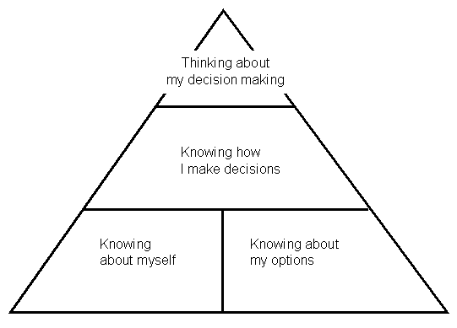The pyramid below shows the elements involved in making a career choice[[2]](#footnote-3):

**Knowing about Myself**, such as

My **values**  
Example: independence

My **interests**  
Example: helping others

My **skills**  
Example: finger dexterity

My **personality**

Example**: artistic**

My **aptitudes f**

Example: strong math ability

**Knowing about My Options**

1. **Learn about specific occupations, programs of study, and jobs**

Examples:   
What are typical work tasks for a real estate appraiser?  
How much math is required for a major in Finance?

What is the average starting salary for a retail salesperson?

What type of training is required to be a physical therapist?

1. 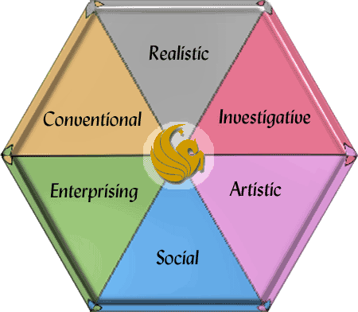**Learn how occupations, programs of study, and people can be organized**

Career Theorist John Holland states that people and work environments correspond and can be loosely classified into six different groups that can be graphed geometrically around the six corners of a hexagram in the following order: Realistic, Investigative, Artistic, Social, Enterprising, and Conventional. While people may have some personality elements that apply to all six groups, they will be most attracted to two or three areas. Holland type is shorthand for describing the personality types people resemble most. Holland Codes can be used to compare people to occupations and work environments. For example, if your interests lie primarily in the Investigative, Realistic, and Social areas, then your Holland Code is IRS. The first letter of your code shows the type you resemble most, the next letter is the type you resemble somewhat, and the third letter the type you resemble but less. (You may want to read **Making Vocational Choices: a Theory of Vocational Personalities and Work Environment**, 3rd edition (1997) by John Holland. See the hexagram above.

1. **Learn about job settings**

Example:

Business/Industry

Government

Education

Non-Profit

Indoors/outdoors

**Knowing How I Make Decisions**

**How do I usually make important decisions?**

Look at how you have made decisions in the past, and note if your techniques have worked well for you. If your typical decision-making strategies work well for you, use these to make a career choice. If your typical strategies have not worked, consider other strategies, such as prioritizing, laddering, or factor analysis, a simple prioritizing strategy that will be introduced later in this lesson.

**Thinking about My Decision-Making**

Decision-making is a way to form and establish identity. When you decide, you define yourself to your*self* and to others. Building confidence in decision-making requires practice, self-knowledge, and belief in yourself.

**Self-talk**Example: "I'll never be able to make a good career choice."

**Self-awareness**  
Example: "I'm getting very scared about this."

**Being aware of and controlling my self-talk**  
Example: "I can't really predict the future and imagining failure is not going to help me find a good job."

**STEPS IN GOOD DECISION MAKING****, LECTURE NOTES**

Figure 1 below graphically represents the steps in making a career choice:

**Knowing I Need to Make a Choice, Antecedents:**

**Events - things that happen to me**  
"I need to choose a program of study by next semester."

**Comments from my friends and relatives**  
"My roommate said that I'll have problems if I don't make a decision soon."

**The way I feel**  
"I'm scared about committing myself to a program of study."

**Avoiding my problems**  
"I'll get started next week."

**Physical problems**  
"I'm so upset about this, I can't eat."

**Understanding Myself and My Options**

**Understanding myself**, such as

My values

My interests

My skills

**Understanding occupations, programs of study, or jobs**

Understanding specific occupations, programs of study, or jobs

Understanding how occupations, programs of study, or jobs are organized

**Understanding how I make important decisions**

Typical decision-making strategies-do they work? If not, learn new techniques.

**Understanding how I think about my decisions**

Self-talk

Self-awareness

Being aware of and controlling my self-talk

**Expanding and Narrowing My List of Occupations, Programs of Study, or Jobs**

**Identify** occupations, programs of study, or jobs that fit my values, interests, and skills

**Pick** the 3 to 5 best occupations, programs of study, or jobs using what I learned from "Understanding Myself and My Options," then do research.

**Choosing an Occupation, Program of Study, or Job**

**Costs** and **benefits** of each occupation, program of study, or job to:   
**myself?**  
my **family?**my **cultural group**  
my **community** or **society?**

Rank occupations, programs of study, or jobs

Make a choice

Make back-up choice(s) in case I have a problem with my first choice

**Implementing My Choice**

**Plan** - Make a plan for getting education or training

**Try Out** - Get work experience (full time, part-time, volunteer) and take courses or get training to test my choice

**Apply** - Apply for and get a job

**Knowing I Made a Good Choice**

Have events changed?

How did my friends and relatives react to my choice?

How do I feel now?

Am I avoiding doing what needs to be done?

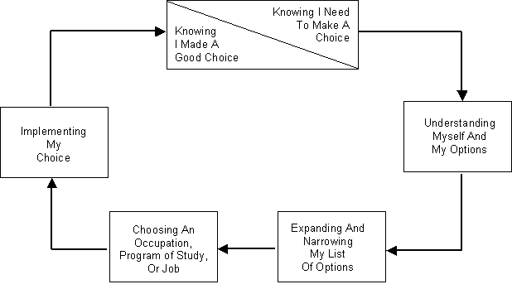

Reprinted from the *Career Development Quarterly, 41*, 1992, p. 70, copyrighted NCDA.

**C:\Users\Susan\AppData\Local\Microsoft\Windows\Temporary Internet Files\Content.IE5\HQD0I7WI\MCBS00867_0000[1].wmfLEARNING TO PRIORITIZE: CHOOSE YOUR FAVORITE SONG**

In college, where your initiative determines your future, you must make many, crucial decisions at every level imaginable. The key to making good decisions is prioritizing among your choices, which is something we do either unconsciously or don’t do, jumping at the easy decision. However, sometimes the relative importance of things is not so obvious but important. Out of the thousands of things we want to do, we have to choose five or six to focus on for a semester. From a brainstormed list, for example, you might need to choose which topics will become the main ones for a paper and which should become mere details. Weighing up the sides of a decision is hard enough when there are only two choices, but what about when there several?

Richard Bolles, who wrote *What Color Is Your Parachute?*, came up with an excellent and graphic way to boil these kinds of situations down to a bunch of two-choice comparisons, then seeing which factors come out most important overall. Here is how his process works:   
  
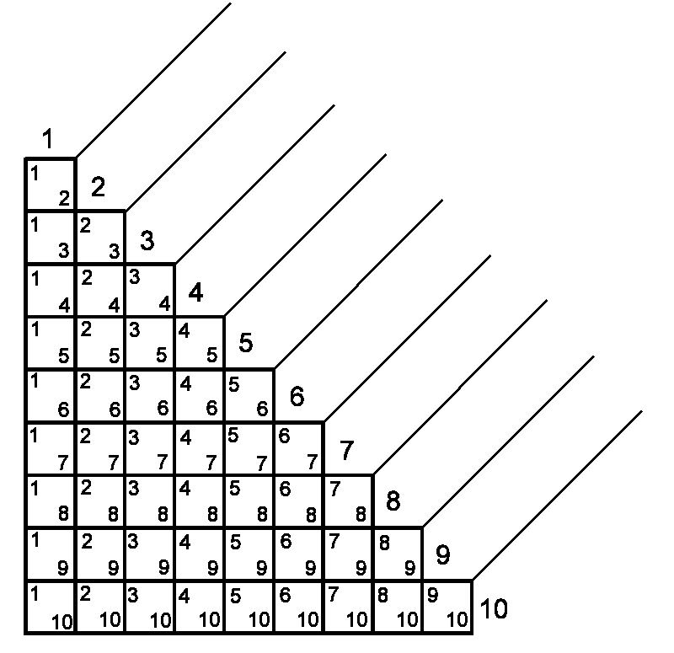  
  
Write the factors associated with your decision-in a positive fashion--on the diagonal slots 1-10. You must word these positively, or you’ll never choose the factor. For example, if you don’t want to commute, write “short commute”. If you wrote, “dislike commuting,” you’d never choose that factor. (If you have more than 10 factors, draw more boxes below these.)

Prioritized List

1.

2.

3.

4.

5.

6.

7.

8

9.

10.

Note, the boxes are arranged so that every item is paired, to be compared with every other. Within each box, circle the number of the item that is more important, more central, more whatever. Sometimes you have to ask yourself an extreme question like you would in an ordinary decision, like "if I could only do one of these before I die, which would it be?" Then tally the number of circles for each item. The one with the most circles is your top priority, and the one with the fewest circles is your lowest priority.

In the case of a two-way tie, re-compare the tied items and see which you selected. Give that item and extra ½ point. In the case of a three-way tie, you’ll need to re-compare the three items, determine which is the highest, medium, and lowest of the three, then give the highest an extra .66 and give the second highest an extra .33 points. Once you have tallied your results, re-list your prioritized factors in the blue box to the right of the grid (your highest priority is #1). This prioritized list should help you see where to begin with your decision, whatever it might be.

For clarity, here is an example, in which the user is attempting to identify his favorite fruit. The candidates are apples, kiwis, bananas, blueberries, and mangoes. Note the tally marks below the grid. Banana got the most marks, and mangoes, never preferred above any other fruit, scored zero—the bottom.

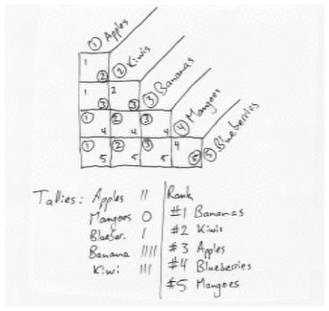

**PRACTICE:** Now try this process for yourself by prioritizing and identifying your favorite song. Begin by listing your 8-10 favorite songs in any order on the diagonal slots of the grid at the top of the previous page. Use the process described above to compare, tally and prioritize your favorite songs. What did you learn?

1. <http://www.salary.com/docs/resources/JobSatSurvey_08.pdf>. [↑](#footnote-ref-2)
2. *The Career Development Quarterly, 41*, 1992, p. 70, copyrighted NCDA. [↑](#footnote-ref-3)